


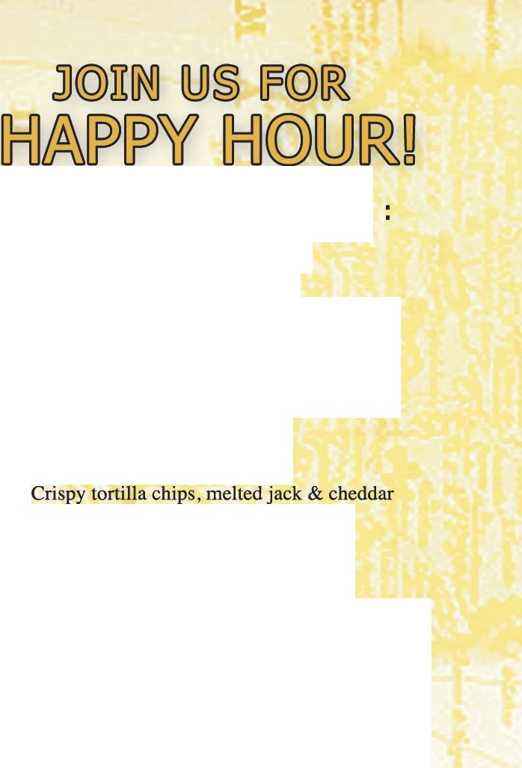


Monday - Friday 2pm - 6pm
Bar & Patio Only

CARNE ASADA FRIES ... $7
Fresh grilled carne asada, crispy french fries, melted jack & cheddar cheese, pico de gallo, sour cream and guacamole

NACHOS ... $5

cheese, pico de gallo
ADD chicken or beef... $7

QUESADILLAS... $5
Warm flour tortilla, melted jack & cheddar cheese, pico de gallo, sour cream and guacamole
ADD chicken or beef... $7

MARGARITAS... $6
TECATE... $350 I $16 pitchers

